**Project 1: Automate Docker built and push using Jenkins file.**

1. **Setup a Simple Flask App**

Project Structure : app.py has main Flask Application File.

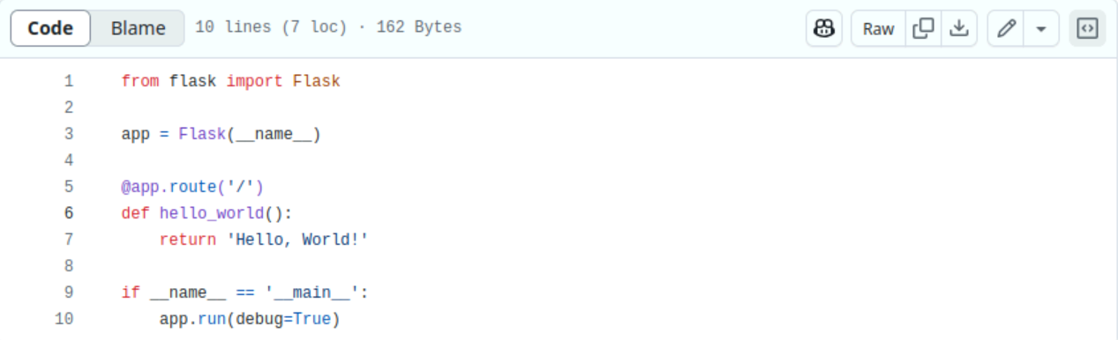

1. **Docker File: Defines the Docker image for the Flask App.**

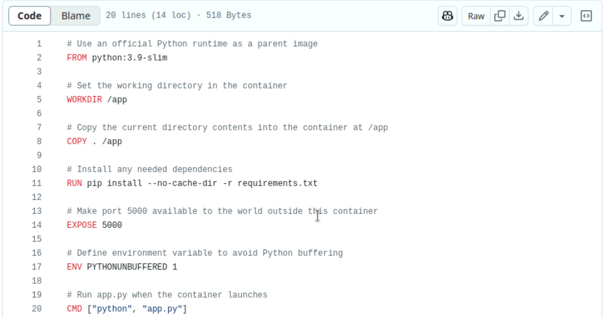

1. **Jenkinsfile : Contains the Jenkins Pipeline Configuration.**

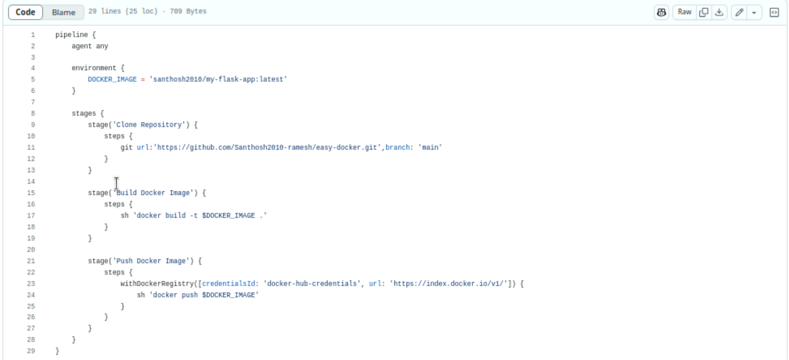

1. **Requirements.txt List of Dependencies (Flask and other)**



1. **Push the code to GitHub**

Make sure you have a GitHub repository created for the project.

Push all the files (app.py, requirements.txt, Docker File, Jenkins File) to the GitHub repository.

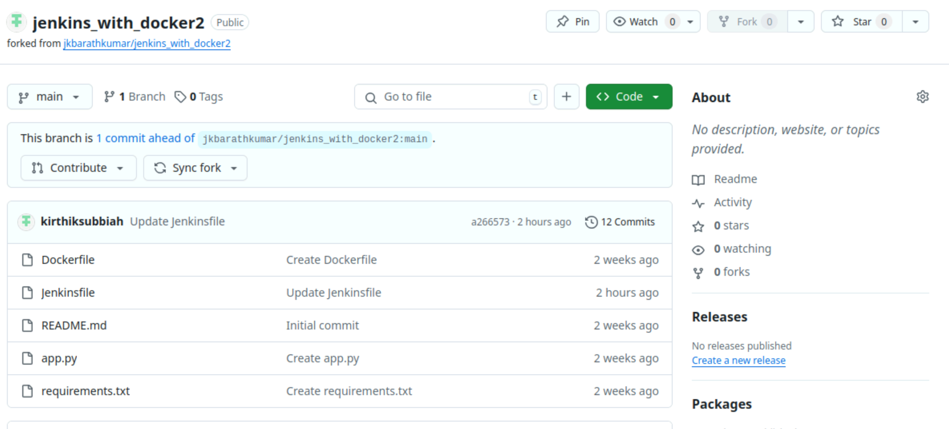

1. **Configure Docker Hub Credentials in Jenkins**

Goto Jenkins > manage Credentials.

Add new Credentials:

Username & Password: You Docker Hub username and password.

ID: Name it something like dockerhub-creds(the same name used in the Jenkinsfile)

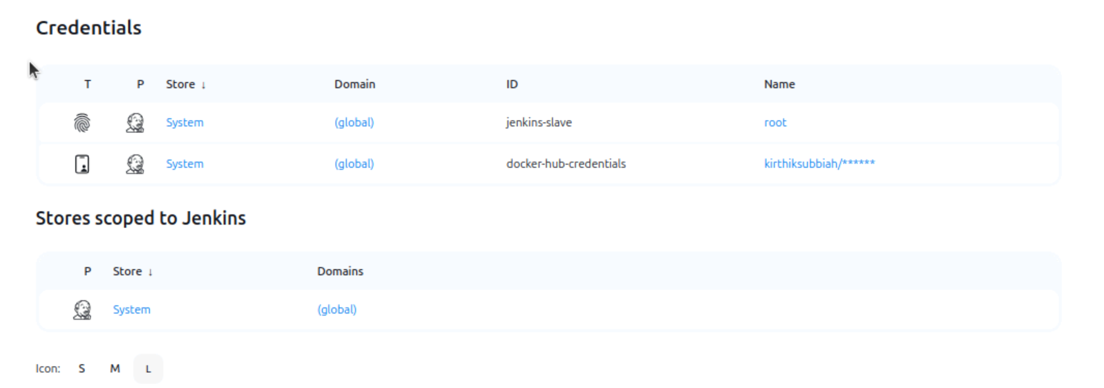

1. **Create a New Pipeline in Jenkinsfile**

In Jenkinsfile, click New Item > Pipeline.

Enter a new for the Pipeline.

Under Pipeline definition, Select Pipeline Script from SCM.

Select Git as the SCm.

Enter the Github repository URL.

Set the branch (typically master or main)

Click Save

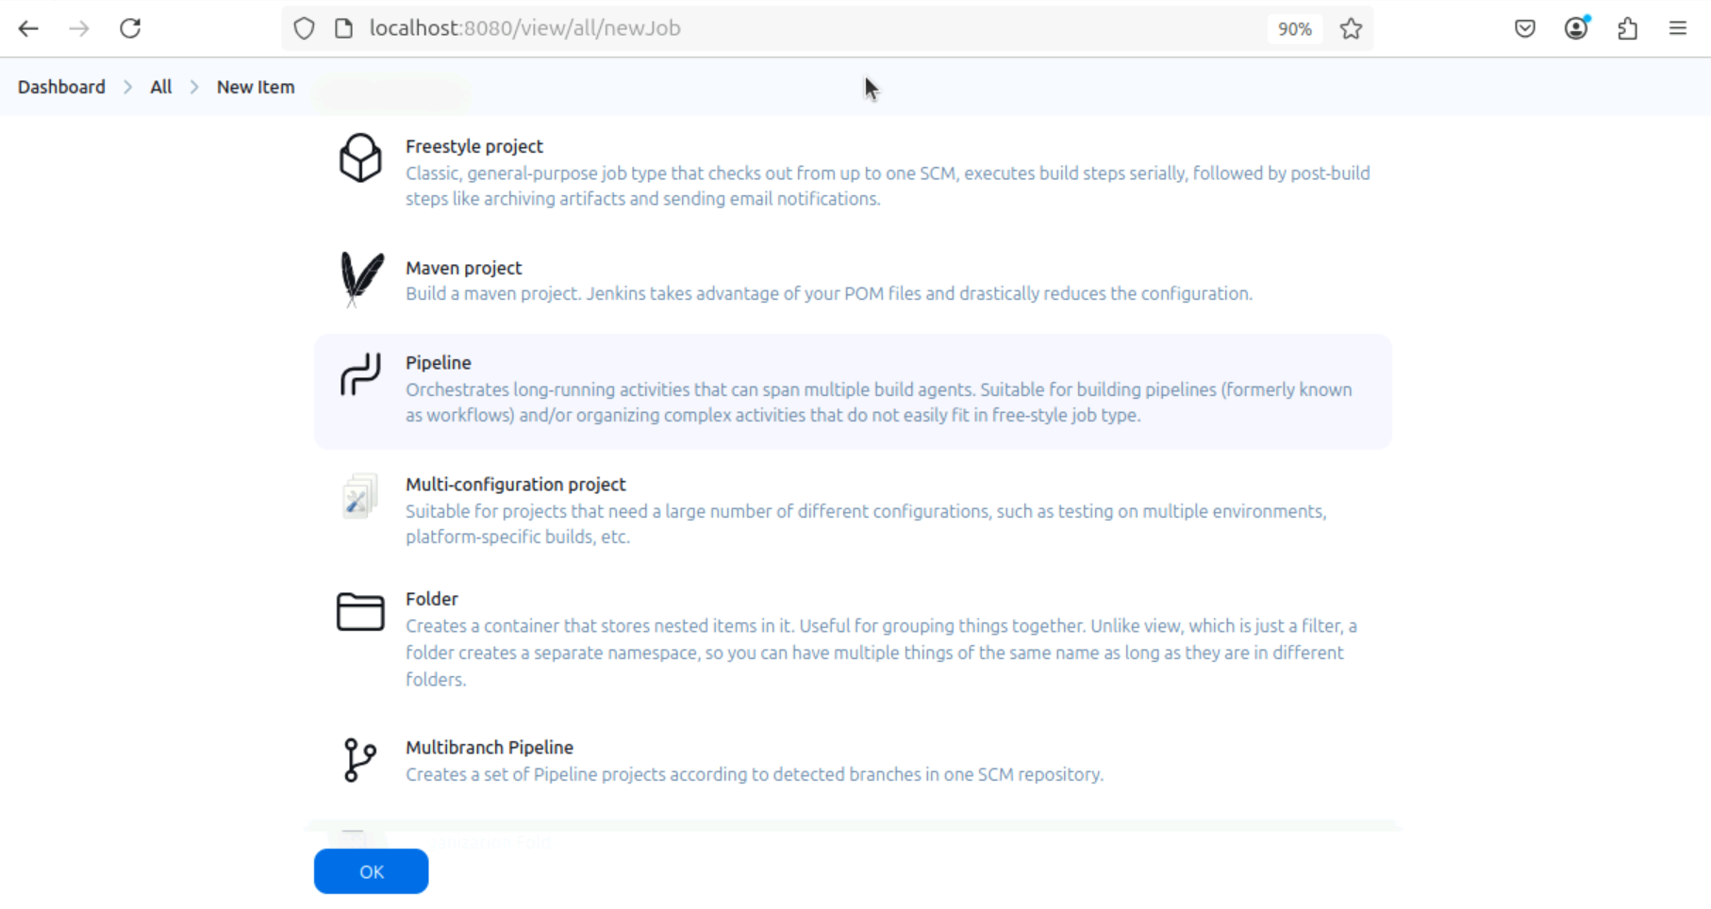

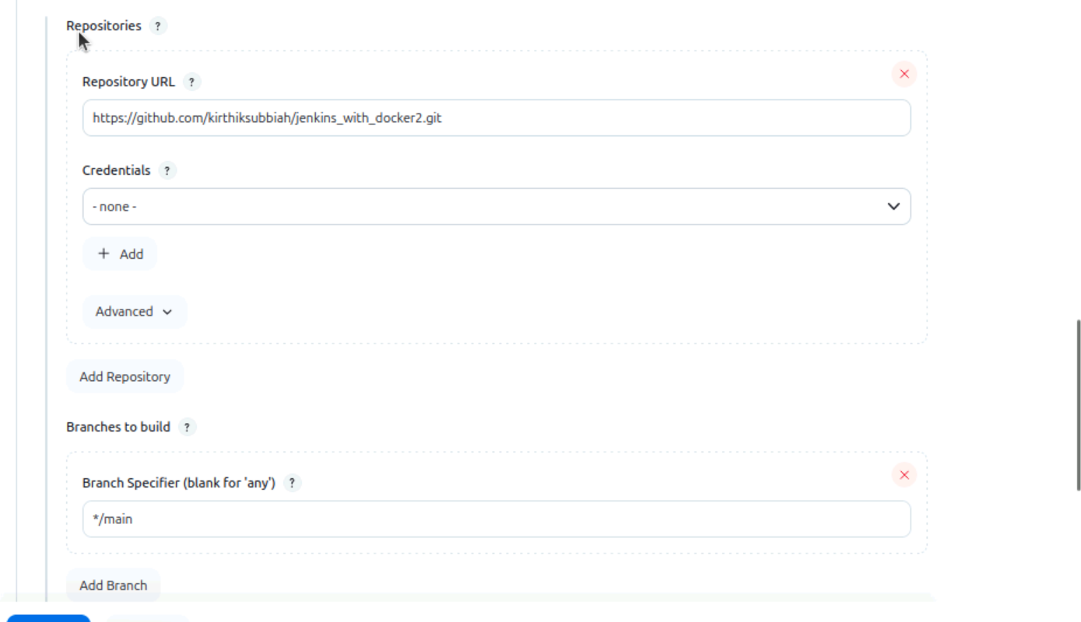

1. **Click Build Now**

Click Build Now in Jenkins to trigger the build.

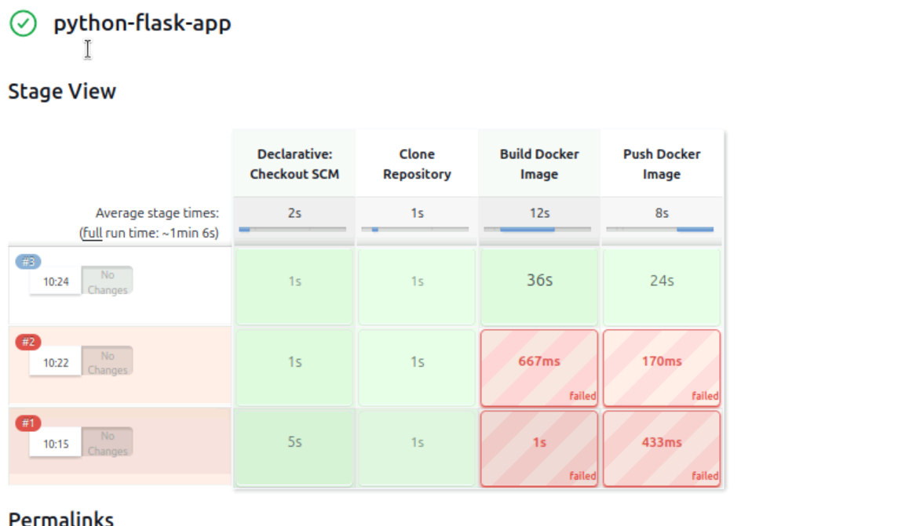

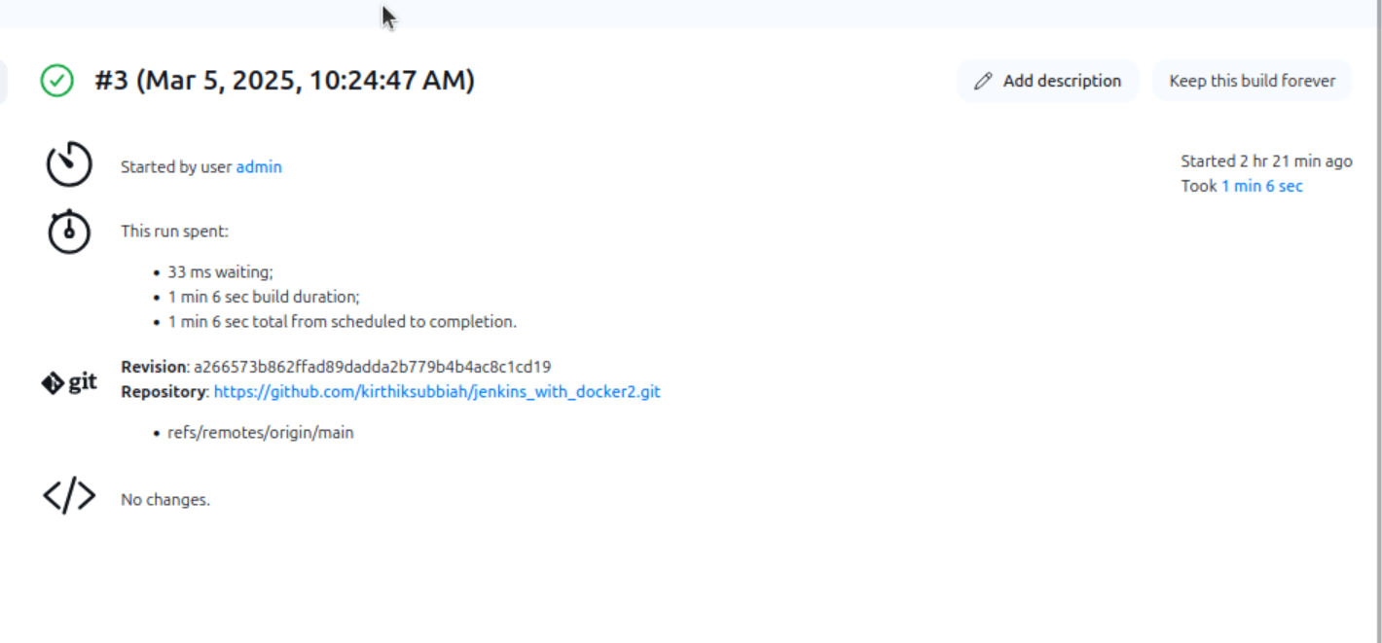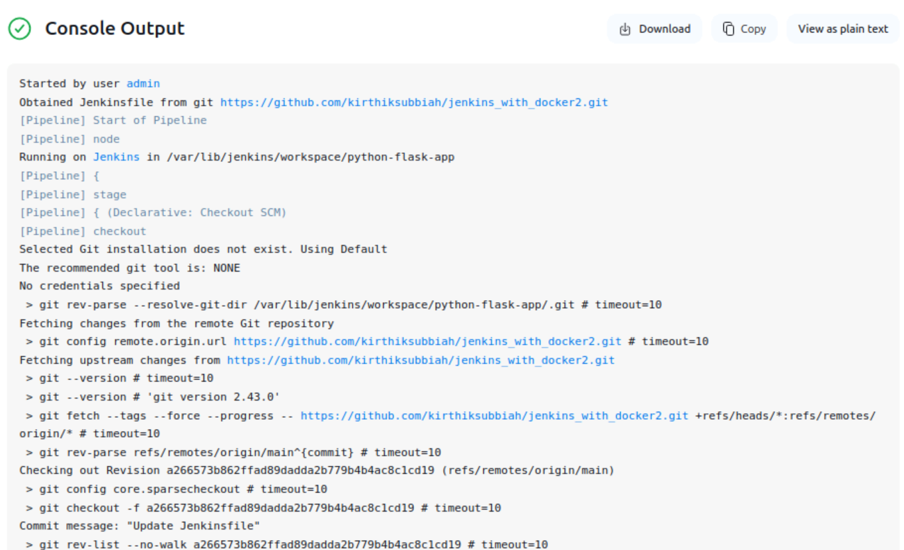

1. **Verify Docker Image on Docker Hub.**

After the Build Finishes, log into your Docker Hub Account.

You should see the my_flask_app image under Repositories with the latest tag.

